Invasion of restored California vernal pools reveals the importance of maintenance and monitoring

Joanna Tang and Madeline Nolan

**Abstract**

Western ideals of restoration often focus on short-term restoration intervention efforts with the goal of creating restored ecosystems that do not require human maintenance. However, mixed success of these short-term implementation efforts questions the efficacy of this approach. Here, we ask: Do short-term restoration efforts result in long-term success or do these restored ecosystems require long-term management to prevent degradation? We address this question using case studies of restored vernal pool wetlands in California. Over the last century, over 90% of California’s vernal pool ecosystems have been lost due to land conversion for human use. Recognition of the importance of wetland ecosystems, including vernal pools, has led to a growing effort to restore these ecosystems and their associated endemic flora and fauna. Restoration efforts are, however, often hindered because restored vernal pools often exist within a grassland matrix and are prone to invasion by exotic annual grasses. We hypothesize that restored vernal pools are susceptible to exotic invasion in the long run because most restoration projects only budget for short-term invasive species control, but portions of the pools are not flooded enough for abiotic exclusion of invasive grasses. To test this, we assessed exotic species abundance and diversity after intensive weeding had ceased in a suite of restored vernal pools along the South Coast of California. We found that exotic species cover and biomass increased over time, particularly around the edges of the pools, especially after 5-6 years. The central bottom of pools, however, showed much less invasion and no trend over time. This increase in exotics around pool edges indicates encroachment of exotic grasses from the upland grassland into the pools. Our findings indicate that restored ecosystems are susceptible to invasion over time, but that this depends on several abiotic and biotic conditions within the ecosystem. Our findings highlight the importance of ongoing monitoring and adaptive management in long-term restoration success and support a paradigm shift away from short-term interventionist restoration and toward viewing restoration as a longstanding relationship with the land.

**Introduction**

Western cultures have largely viewed restoration actions as short-term interventions. Invasive species management in restoration projects is often heavily frontloaded due to budget constraints. Yet, such frontloading does not guarantee a restored ecosystem’s long-term resistance to invasion. Indeed, exotic species are one of the major impediments to successful restoration (Aradottir & Hagen 2013). For example, Gutrich, Taylor & Fennessy (2009) showed that restored wetlands may attain high native species cover during the first few years after restoration, but native cover subsequently declines in the long run due to an increase in invasive exotic species cover.

Invasion by exotic species in restored vernal pool ecosystems is of special concern. California’s vernal pools form atop an impermeable subsurface soil layer during the cool, wet winters of California’s Mediterranean climate. Endemic plants and animals grow and reproduce quickly during the spring, before the pools completely desiccate during the warm, dry summers. These species are specially adapted to grow and reproduce quickly during the spring, and their seeds or eggs can remain dormant in the dry soil until the next winter rains arrive. Vernal pools, which often form within a flat grassland matrix, are especially prone to invasion by exotic annual grasses that now dominate most of California’s grassland ecosystems. California’s highly endemic vernal pool ecosystems are facing increased exotic species invasion exacerbated by global change. Over 90% of California’s vernal pools have been degraded or destroyed, largely due to urbanization, agriculture, and grazing (Mooney & Zavaleta 2016).

Vernal pool restoration that began in southern California the 1980s typically consisted of one-time restoration efforts. We define one-time restoration efforts as time-constrained habitat restoration or creation projects that have a defined project scope (e.g., defined budget, goals, and start and end dates). These projects are typically funded to be implemented in a 1-5-year time span, with an “implementation phase” that involves substantial money, labor, equipment, and other resources to alter the abiotic environment, remove exotic species, and introduce native species (Gann et al. 2019). These one-time restoration efforts often have short-term success criteria, e.g., achieving 90% native plant cover within 5 years of project implementation. However, these short-term objectives are only proxies for long-term success (Nilsson et al. 2016). The overarching goal of restoration is to restore an ecosystem to its dynamic trajectory, and long-term success can be determined through long-term monitoring. Does the restoration site maintain 90% native cover in the long run? The achievement of short-term goals can be indicative of long-term success; however, if human actions push an ecosystem out of its invaded state, what happens when that human force is removed? As restored ecosystems face ongoing threats posed by invasive species, we might expect invasion pressure (e.g., high exotic propagule supply or multiple exposures to exotic species introductions) to push a restored ecosystem back to an invaded state. Climate change further favors invasive species, especially as increased drought precludes pool formation (Faist & Beals 2018). Does this susceptibility to invasion threaten the long-term success of these restoration projects, i.e., do native species remain dominant and do exotic populations remain low over time?

We investigated the long-term success of a set of 69 restored vernal pools, using native and exotic plant cover and diversity as metrics for success. Several pool complexes were restored or created between 1980 and 2017, with restoration efforts encompassing pool basin excavation, slope grading, pool perimeter berm enhancement, exotic plant species removal, and native plant and invertebrate species introduction. One short-term restoration goal, which was achieved, was to reduce exotic plant cover throughout the pools to 10% within five years of restoration (Ferren, *unpublished data*). If short-term metrics forecast long-term success, then the restored pools should retain >90% native plant cover and <10% exotic plant cover past for longer periods (>5 years; H1.1). If native plant cover remains high and exotic plant cover remains low over time, this indicates that restoration efforts produced both short-term and long-term success.

Alternatively, climatic factors (e.g., interannual precipitation and temperature variability), other abiotic factors (e.g., soil characteristics or fertilization), and biotic factors (e.g., competition, propagule supply, herbivory) could reverse the outcomes of one-time restoration efforts and cause exotic plant cover to increase (H1.2). If exotic plant cover in restored pools increases and/or native plant cover decreases over time, then this indicates that abiotic and/or biotic site factors are facilitating exotic invasion and/or suppressing native populations. For example, invasive species that are abundant throughout the surrounding area, including in nearby unrestored open spaces, can provide a source of exotic propagule supply. Vectors (e.g., humans, other animals, and wind) disperse propagules throughout invaded and restored ecosystems, allowing for the spread of invasive species. Climate change, which is causing prolonged drought conditions, may also reduce native germination (because the pools do not fill with water or remain inundated for adequate amounts of time) and promote invasion (because generalist exotic species can invade dry open niche space; Zedler 1987).

If restoration legacy effects are being overpowered by other biotic and abiotic conditions that favor a specific suite of invasive species, then those few species could dominate the community, and both native and exotic richness may decrease. For example, Davies (2011) showed that the invasion of the annual grass *Elymus caput-medusae* caused a decrease in species richness, indicating that *E. caput-medusae* formed a monoculture. If only native species richness decreases, then this indicates that biotic and abiotic conditions are disfavoring native species. For example, Valliere et al. (2017) showed that anthropogenic nitrogen deposition and drought caused native shrub canopy loss. This may subsequently cause an increase in exotic species as native species die out and leave open niche spaces to be colonized by exotic species (Norton, Monaco, & Norton 2007). In either case, the success criteria of >90% native plant cover and <10% exotic plant cover may not be maintained in the long run.

To look more closely at the shifting vegetation dynamics in restored vernal pools after the implementation phase, we coupled the chronosequence study with multi-year vegetation surveys on a subset of pools. After the completion of the initial restoration implementation, we continued to monitor the pools into the “maintenance phase”, which included some periodic weeding. We hypothesized that, if other biotic and abiotic conditions overpowered restoration legacy effects, exotic plant cover would begin to increase after the completion of the implementation phase (H2.1). Because generalist exotic annual grasses are unable to withstand prolonged inundation, while endemic vernal pool assemblages are adapted to the highly dynamic hydrologic regime of vernal pools, we further hypothesized that exotic plant abundance would be most pronounced around the pool edges where pool inundation and associated abiotic resistance is smallest and distance from the invasion front is shortest (H2.2).

**Methods**

*Study Area*

This study was conducted on land managed by the University of California, Santa Barbara, in Santa Barbara County, California, USA. This land is part of unceded ancestral territory of the Chumash people. The study area lies within one mile or less of the Pacific Ocean, and experiences a Mediterranean climate that is cool (13.3ºC average) and wet during the months of November-April, and warm (15.6ºC average) and dry during the remainder of the year. Rainfall averages approximately 17 inches per year with notable variation often exacerbated by extreme rainfall events and droughts (PRISM 2019; https://prism.oregonstate.edu). The close proximity to the Pacific Ocean moderates winter lows and frost is relatively rare. Summer fog likewise moderates summer temperatures although offshore “sundowner” winds may bring hot dry conditions over 90ºF to the area, especially in the late summer and fall. Soil formation is typically the result of weathering of uplifted shales and are dominated by clay. Soils are Mollisols, and dominant soil series include Concepcion fine sandy loam and Diablo clay (Soil Survey Staff 2022).

*2019 Chronosequence Survey*

69 pools were restored at different points in time (2 to 33 years before 2019), but because all the restored pools share similar attributes in terms of past and restored abiotic and biotic conditions, I was able to construct a chronosequence that uses a space-for-time substitution to track the effect of time since restoration on native and nonnative cover and richness.

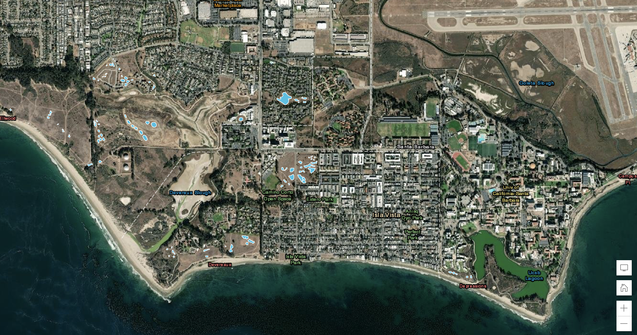

Figure . Figure 1. Map showing 69 surveyed pools (highlighted in blue) throughout 9 sites: Del Sol Vernal Pool Preserve (11 pools), Camino Corto Open Space (7 pools), Manzanita Village (5 pools), North Campus Open Space (8 pools), North Parcel (9 pools), Sierra Madre (1 pool), South Parcel (10 pools), Storke Ranch (5 pools), West Campus Bluffs (12 pools).

Abiotic Variables Survey

To measure hydrology, we installed 0.8-m rulers in the deepest part of each pool in January 2019. We recorded water height of each pool every week until the pools dried up (March-July). To measure site and pool size, we used a Trimble GPS to map out the perimeter of the sites and the pools.

Vegetation Survey

In the spring of 2019, we conducted vegetation surveys in each pool. For each pool, we laid out two transects bisecting the elliptical pool along its major and minor axes (Figure 2). Along each transect, we laid down a 1 m x 1 m quadrat with 10% subdivisions every other meter. For each quadrat, we identified every plant species present and estimated its percent cover. Because low-growing graminoids and forbs were overlaid with taller species, total percent cover could exceed 100% in each quadrat. We also estimated percent cover of bare ground and thatch. We also categorized each quadrat as being in the “central zone” (fully inundated for the longest time), “transition zone” (inundated half as long as the bottom zone but with hydric soil), or “upland zone” (non-hydric soil) of the pool.

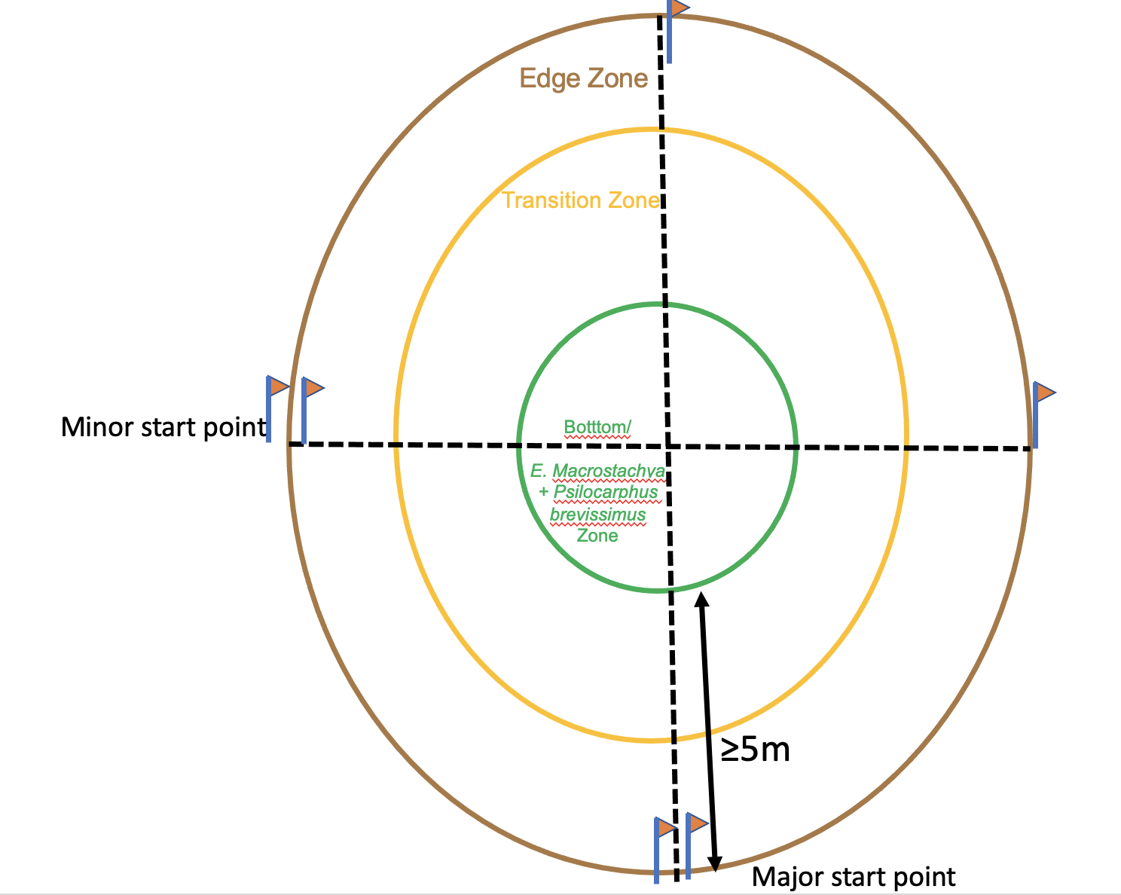

Figure 2. Schematic of sampling transect design for each pool in 2019 chronosequence.

*Multi-Year Monitoring Experiment*

Focal Vernal Pools

To take a closer look at the interaction between vegetation dynamics after initial restoration actions had ceased and interannual variability, we monitored 7 restored vernal pools within the management unit named North Parcel (Figure 1). The pools were created between 2011 and 2014 as part of a mitigation site. Pools varied in size and depth (Appendix 1), but all 7 pools were managed in a similar fashion, including grading to carve out pool basins and then introduction of approximately 140 species of locally-sourced native plants from vernal pool, vernal marsh, coastal prairie, and coastal sage scrub assemblages. Vegetation was purposely planted in patches to mimic landscape patterns generally observed in nature, according to soil types, hydrology, and other site factors. Installed plantings were watered-in using mainly moveable drip irrigation until establishment was achieved. Exotic species were controlled mainly by hand-weeding, although solarization, herbicide, and green flaming were also employed to a lesser degree. This implementation phase of this restoration project lasted 5 years.

Experimental Design

Within each restored vernal pool, we set up a series of permanent monitoring quadrats. As in the chronosequence survey, we delineated each pool into central, transition, and edge upland (Figure 3). Within each of these zones (central, transition, and upland) we haphazardly placed three 1m2 quadrats for a total of nine quadrats per pool.



Figure 3. Schematic of zones and representation of the haphazard distribution of the quadrats in each pool in multi-year monitoring experiment.

Data Collection

From November 2016 to December 2019, we monitored the plant communities in each vernal pool every month. Within each quadrat, we assessed the identity and percent cover of all species present. We counted the number of native and exotic species to find native and exotic species richness. We also estimated the number and percent cover of germinating seedlings for native species. Because low-growing graminoids and forbs were overlaid with taller species, total percent cover could exceed 100% in each quadrat. For exotic species, we destructively sampled all exotic species every month in each quadrat. We also assessed percent cover of bare ground, water, and thatch.

The harvested exotic species biomass was dried in an 60ºC oven for at least 48 hours and then weighed on a Fisher Scientific accuSeries®4102, Mettler PM400, and Mettler PC440 digital scales.

*Data Analysis*

All data analysis was performed in RStudio version 1.4.1106. The **glmer** function of the “lme4” package was used to generate generalized linear mixed effects models. The **anova** function from the “stats” package was used to perform analyses of variance. The **emmeans** function from the “emmeans” package was used to perform post-hoc Tukey’s least-squares means comparisons. All graphs were generated using the functions in the package “ggplot2”.

2019 Chronosequence Data

We summed the percent cover of each exotic species to calculate the total exotic cover in each quadrat. We averaged all the quadrats from each pool to calculate mean total exotic cover for each pool. Raw data did not follow a normal distribution according to histogram and Q-Q plot analyses. Instead, raw data were used to construct a generalized linear mixed effects model with a gamma distribution, using a “logit” link function. We included site area, pool age, pool area, and pool inundation period as fixed effects. We included restoration site as a random effect. We used the same fixed and random effects to construct a similar generalized linear mixed effects model for mean total native cover for each pool. Additionally, we calculated the Shannon’s Index of Diversity for native species in each pool and constructed a generalized linear mixed effects model with the same fixed and random effects as the cover models. Model predictions for pool age and zone were compared using an ANOVA and post-hoc Tukey’s tests to determine differences in cover and diversity over time in each zone. An alpha of *p* < 0.1 determined significant differences.

Multi-Year Monitoring Data

From monthly species percent cover data, monthly total exotic species cover was calculated for each quadrat. The maximum total exotic species cover per year was extracted from this dataset. This distribution was skewed right according to histogram and Q-Q plot analyses, which precluded an ANOVA on raw data. Instead, raw data were used to construct a generalized linear mixed effects model with a negative binomial distribution because data were overdispersed compared to a Poisson distribution. In this model, maximum total exotic species cover was predicted by the age of the pool and the zone, and the interaction thereof, with monitoring year, quadrat, pool depth, and pool area included as random effects. Model predictions for pool age and zone were compared using an ANOVA and post-hoc Tukey’s tests to determine differences in exotic cover each year in each zone. An alpha of *p* < 0.1 determined significant differences.

Similarly, monthly total native species cover was calculated for each quadrat. The maximum total native species cover per year was extracted from this dataset. This distribution was normally distributed according to histogram and Q-Q plot analyses, so raw data were used to construct a linear mixed effects model. In this model, maximum total native species cover was predicted by the age of the pool and the zone, and the interaction thereof, with monitoring year, quadrat, pool depth, and pool area included as random effects. Model predictions for pool age and zone were compared using an ANOVA and post-hoc Tukey’s tests to determine differences in native cover each year in each zone. An alpha of *p* < 0.1 determined significant differences.

Monthly exotic biomass was summed to calculate total annual biomass for a given growing season. This distribution was skewed right according to histogram and Q-Q plot analyses, which precluded an ANOVA on raw data. Instead, raw data were used to construct a generalized linear mixed effects model with a gamma distribution, using a “logit” link function. In this model, total annual exotic biomass was predicted by the age of the pool and the zone, and the interaction thereof, with monitoring year, quadrat, pool depth, and pool area included as random effects. Model predictions for pool age and zone were compared using an ANOVA and post-hoc Tukey’s tests to determine differences in exotic biomass over time in each zone. An alpha of *p* < 0.1 determined significant differences.

Monthly total native species Shannon’s Index of Diversity was also calculated for each quadrat. The maximum total native Shannon’s Index of Diversity per year was extracted from this dataset. This distribution was not normally distributed according to histogram and Q-Q plot analyses, which precluded an ANOVA on raw data. Instead, raw data were used to construct a generalized linear mixed effects model with a gamma distribution, using a “logit” link function. In this model, maximum total native Shannon’s Index of Diversity was predicted by the age of the pool and the zone, and the interaction thereof, with monitoring year, quadrat, pool depth, and pool area included as random effects. Model predictions for pool age and zone were compared using an ANOVA and post-hoc Tukey’s tests to determine differences in exotic cover each year in each zone. An alpha of *p* < 0.1 determined significant differences.

**Results**

*2019 Chronosequence*

Our generalized linear mixed effects model indicated a significant positive relationship between exotic cover and pool age (*p* < 0.01; Table 1). This model showed that exotic plant cover increased the most in the upland zone, followed by the transition zone, and with only a slight increase in the central zone (Figure 4). Average total exotic cover ranged from 0% to 94.19% in the central zone, from 0.19% to 113.17% in the transition zone, and from 0.79% to 160.70% in the edge zone. Furthermore, although exotic cover was <10% in younger pools, it increased past 10% in the transition zone in pools 14 years and older, and in the upland zone in pools 8 years and older. Other abiotic factors significantly correlated with higher exotic cover, with shorter inundation period (*p* = 0.014) and smaller pool area (*p* < 0.001) predicting higher exotic cover (Table 1).

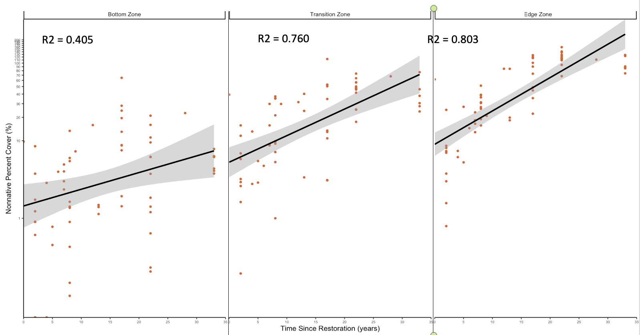

Figure 4. Total average exotic percent cover per pool zone over time in 2019 chronosequence, shown with linear models with 95% confidence intervals.

Table 1. ANOVA table for Exotic Percent Cover GLMER for 2019 chronosequence.

zone_nonnative_pc_glmer <- glmer((avg_nonnative_pc+1) ~ (time_since) + vegetation_zone + time_since*vegetation_zone + (1|location) + (parcel_size) + (period) + (area) + area*vegetation_zone, family = Gamma(link = "log"), zone_pool_avg_pc_h)

|  |  |  |  |
| --- | --- | --- | --- |
|  | **Exotic Percent Cover** | | |
| *Predictors* | *Estimates* | *CI* | *p* |
| (Intercept) | 9.76 | 9.67 – 9.84 | **<0.001** |
| pool age | 1.01 | 1.00 – 1.02 | **0.003** |
| vegetation zone [upland] | 3.95 | 3.92 – 3.99 | **<0.001** |
| vegetation zone [transition] | 2.66 | 2.63 – 2.68 | **<0.001** |
| parcel size | 1.00 | 1.00 – 1.00 | 0.274 |
| inundation period | 1.00 | 0.99 – 1.00 | **0.014** |
| pool area | 1.00 | 1.00 – 1.00 | **<0.001** |
| pool age * vegetation zone [upland] | 1.01 | 1.00 – 1.02 | **0.027** |
| pool age * vegetation zone [transition] | 0.99 | 0.99 – 1.00 | 0.167 |
| vegetation zone [upland] * area | 1.00 | 1.00 – 1.00 | **0.002** |
| vegetation zone [transition] * pool area | 1.00 | 1.00 – 1.00 | **0.004** |
| **Random Effects** | | | |
| σ2 | 0.42 | | |
| τ00 restoration site | 0.23 | | |
| ICC | 0.36 | | |
| N restoration site | 9 | | |
| Observations | 207 | | |
| Marginal R2 / Conditional R2 | 0.547 / 0.710 | | |

Exotic species richness ranged from 0 to 22 in the central zone, from 2 to 29 in the transition zone, and from 5 to 39 in the edge zone. The most abundant exotic invasive species was *Festuca perennis*, and other grasses and forbs listed by the California Invasive Plant Council as invasive species capable of displacing native species and forming monocultures that were present in the pools include *Festuca myuros*, *Polypogon monospeliensis*, *Bromus diandrus*, *Bromus hordeaceus*, *Avena fatua*, *Hordeum marinum*, *Plantago lanceolata*, and *Lythrum hyssopifolia* (California Invasive Plant Council 2022; <https://www.cal-ipc.org/plants/inventory/>).

Although native cover remained relatively stable in the central and transition zones as the pools aged, it significantly decreased, below 90%, in the upland zone (Figure 5). Average total native cover in ranged from 1.27% to 239.00% in the central zone, from 1.76% to 229.20% in the transition zone, and from 0% to 106.90 in the upland zone. Moreover, the Shannon’s Index of Diversity for native species significantly decreased in both the transition and upland zones (Figure 6). Average native Shannon’s Index of Diversity ranged from 0.053 to 1.531 in the central zone, from 0 to 1.587 in the transition zone, and from 0 to 1.534 in the edge zone. Native species richness ranged from 3 to 22 in the central zone, from 3 to 29 in the transition zone, and from 0 to 32 in the upland zone. *Eleocharis machrostachya* was the most dominant native species, followed by *Eryngium vaseyi* and *Eleocharis acicularis* in the central transition zones and *Stipa pulchra* in the upland zone.

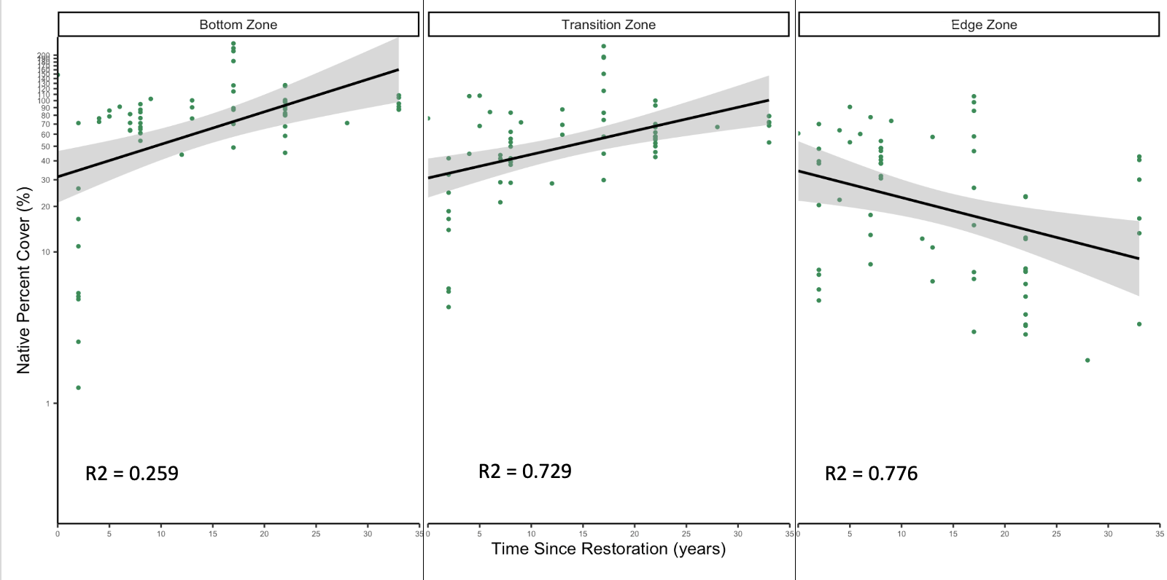

Figure 5. Total average native percent cover per pool zone over time in 2019 chronosequence, shown with linear models with 95% confidence intervals.

Table 2. ANOVA table of Native Percent Cover GLMER for 2019 chronosequence.

zone_native_pc_glmer <- glmer((avg_native_pc+1) ~ (time_since) + vegetation_zone + time_since*vegetation_zone + (1|location) + (parcel_size) + (period) + (area) + (avg_nonnative_pc), family = Gamma(link = "log"), zone_pool_avg_pc_h)

|  |  |  |  |
| --- | --- | --- | --- |
|  | **Native Percent Cover** | | |
| *Predictors* | *Estimates* | *CI* | *p* |
| (Intercept) | 39.19 | 14.95 – 102.72 | **<0.001** |
| pool age | 1.01 | 0.99 – 1.04 | 0.229 |
| vegetation zone [upland] | 0.78 | 0.55 – 1.10 | 0.159 |
| vegetation zone [transition] | 0.89 | 0.62 – 1.30 | 0.558 |
| inundation period | 1.00 | 1.00 – 1.01 | 0.643 |
| pool area | 1.00 | 1.00 – 1.00 | **0.001** |
| pool age * vegetation zone [upland] | 0.96 | 0.94 – 0.98 | **<0.001** |
| pool age * vegetation zone [transition] | 0.99 | 0.97 – 1.01 | 0.322 |
| **Random Effects** | | | |
| σ2 | 0.50 | | |
| τ00 restoration site | 0.27 | | |
| ICC | 0.35 | | |
| N restoration site | 9 | | |
| Observations | 207 | | |
| Marginal R2 / Conditional R2 | 0.231 / 0.500 | | |

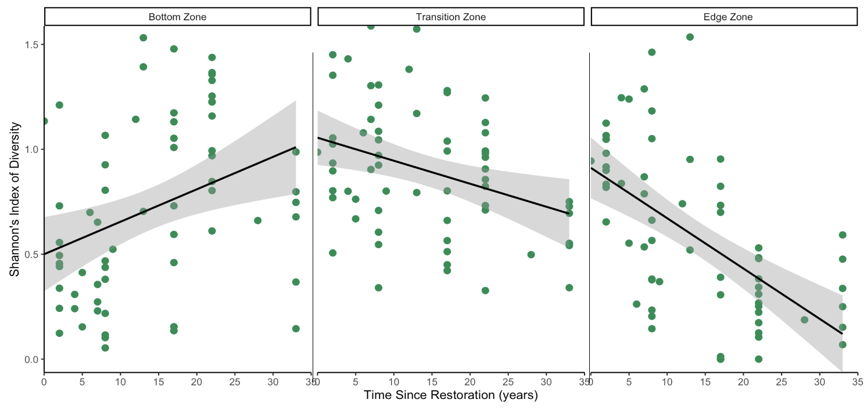

Figure 6. Average Shannon’s Index of Diversity for native plant species per pool zone over time in 2019 chronosequence, shown with linear models with 95% confidence intervals.

Table 3. ANOVA table of Native Shannon’s Index of Diversity GLMER for 2019 chronosequence.

zone_native_h_glmer <- glmer((avg_native_h+1) ~ (time_since) + vegetation_zone + time_since*vegetation_zone + (1|location) + (period) + (area), family = Gamma(link = "log"), zone_pool_avg_pc_h)

|  |  |  |  |
| --- | --- | --- | --- |
|  | **Shannon’s Index of Diversity for Native Species** | | |
| *Predictors* | *Estimates* | *CI* | *p* |
| (Intercept) | 1.71 | 1.31 – 2.22 | **<0.001** |
| pool age | 1.00 | 0.99 – 1.01 | 0.831 |
| vegetation zone [upland] | 1.24 | 1.12 – 1.37 | **<0.001** |
| vegetation zone [transition] | 1.37 | 1.24 – 1.52 | **<0.001** |
| inundation period | 1.00 | 1.00 – 1.00 | 0.801 |
| pool area | 1.00 | 1.00 – 1.00 | 0.616 |
| pool age * vegetation zone [upland] | 0.98 | 0.97 – 0.99 | **<0.001** |
| pool age * vegetation zone [transition] | 0.99 | 0.98 – 0.99 | **<0.001** |
| **Random Effects** | | | |
| σ2 | 0.03 | | |
| τ00 restoration site | 0.01 | | |
| ICC | 0.14 | | |
| N restoration site | 9 | | |
| Observations | 207 | | |
| Marginal R2 / Conditional R2 | 0.442 / 0.517 | | |

*Multi-Year Monitoring Experiment*

In the multi-year monitoring experiment, the most common exotic species found in the vernal pools were a suite of invasive grasses, including *Polypogon monspeliensis*, *Bromus hordeaceus*, *Bromus diandrus*, *Poa annua*, *Festuca myuros*, *Festuca perennis*, and *Hordeum murinum*. In the central zone, maximum annual exotic species richness ranged from 4 to 10, and maximum annual native species richness ranged from 5 to 12. In addition to invasive grasses, we found some exotic forbs including *Helminthotheca echiodes*, *Geranium dissectum*, *Sonchus oleraceus*, and *Medicago polymorpha*. However, plant cover in the central zone was dominated by native species, including *Eleocharis macrostachya*, *Juncus mexicanus*, and *Juncus phaeocephalus*. Maximum annual native cover ranged from 5% to 194%, while maximum annual exotic cover ranged from 1% to 16%. In the transition zone, maximum annual exotic species richness ranged from 15 to 25, and maximum annual native species richness ranged from 7 to 24. In addition to invasive grasses, we found some exotic forbs including *Plantago coronopus*, *Spergularia* spp., *Geranium dissectum*, *Centaurium tenuiflorum*, *Lysimachia arvensis*, *Lythrum hyssopifolia*, *Rumex crispus*, and *Sonchus asper*. Maximum annual native cover ranged from 23% to 146%, while maximum annual exotic cover ranged from 1% to 82%. Dominant native species in the transition zone included *Carex praegracilis* *Eleocharis macrostachya*, *Distichlis spicata*, *Juncus mexicanus*, and *Elymus triticoides*. Native species still dominated, with maximum native exotic cover ranging from 23% to 146% and maximum annual exotic cover ranging from 1% to 82%. In the upland zone, maximum annual exotic species richness ranged from 22 and 28, and maximum annual native species richness ranged from 10 to 23. In addition to invasive grasses, we found some exotic forbs including *Centaurium tenuiflorum*, *Medicago polymorpha*, *Vicia villosa*, *Vicia sativa*, *Geranium dissectum*, and *Melilotus* spp. Dominant native species in the upland zone included *Stipa pulchra*, *Cyperus eragrostis*, and *Hordeum brachyantherum*. Native species still dominated, with maximum annual native cover ranging from 4% to 123% and maximum annual exotic cover ranging from 1% to 62%.

In the multi-year monitoring experiment, we again saw that total exotic species cover significantly increased as pools aged, but only in the transition and upland zones (Figure 7). Post-hoc Tukey’s tests of generalized mixed effects model outputs indicate that, in the transition zone, exotic species cover significantly increased as the pools aged from 3 to 5 years old (*p* = 0.006; S4). In the upland zone, exotic species cover significantly increased as the pools aged from 4-5 years old (*p* = 0.0071; S4). There was no significant increase in exotics in the central zone.

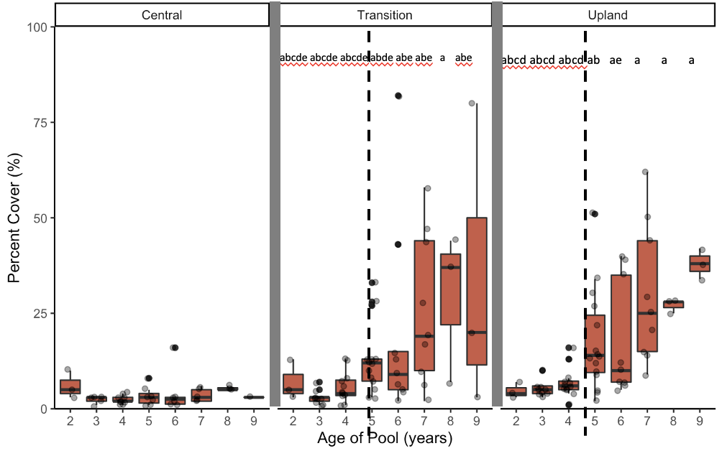

Figure 7. Total exotic cover in restored vernal pool zones over time. Boxplots show median and interquartile ranges. Letters show significant differences for post-hoc Tukey’s tests on generalized linear mixed effects model predictions (alpha = 0.1).

Table 4. ANOVA table of Exotic Cover GLMER for multi-year monitoring experiment.

exotic_pc_glmer <- glmer.nb((max_annual_exotic_pc) ~ as.factor(Time_Since) + Replicate_Zone + as.factor(Time_Since):Replicate_Zone + (1|Year) + (1|depth) + (1|size) + (1|plot_replicate), data = np_annual_total_exotic)

|  |  |  |  |
| --- | --- | --- | --- |
|  | **(Exotic Percent Cover)** | | |
| *Predictors* | *Incidence Rate Ratios* | *CI* | *p* |
| (Intercept) | 5.80 | 2.44 – 13.79 | **<0.001** |
| pool age [3] | 0.44 | 0.17 – 1.17 | 0.100 |
| pool age [4] | 0.42 | 0.16 – 1.10 | 0.079 |
| pool age [5] | 0.44 | 0.15 – 1.29 | 0.134 |
| pool age [6] | 0.51 | 0.17 – 1.55 | 0.233 |
| pool age [7] | 0.60 | 0.18 – 2.01 | 0.404 |
| pool age [8] | 0.92 | 0.27 – 3.14 | 0.894 |
| pool age [9] | 0.47 | 0.07 – 3.05 | 0.427 |
| vegetation zone [transition] | 1.17 | 0.38 – 3.63 | 0.788 |
| vegetation zone [upland] | 0.88 | 0.27 – 2.83 | 0.831 |
| pool age [3] * vegetation zone [transition] | 0.91 | 0.25 – 3.30 | 0.891 |
| pool age [4] * vegetation zone [transition] | 1.90 | 0.55 – 6.51 | 0.307 |
| pool age [5] * vegetation zone [transition] | 3.53 | 0.96 – 13.06 | 0.059 |
| pool age [6] * vegetation zone [transition] | 3.84 | 0.99 – 14.88 | 0.051 |
| pool age [7] * vegetation zone [transition] | 4.38 | 1.09 – 17.65 | **0.038** |
| pool age [8] * vegetation zone [transition] | 5.94 | 1.18 – 29.96 | **0.031** |
| pool age [9] * vegetation zone [transition] | 9.67 | 1.17 – 79.71 | **0.035** |
| pool age [3] * vegetation zone [upland] | 1.94 | 0.53 – 7.09 | 0.314 |
| pool age [4] * vegetation zone [upland] | 2.94 | 0.84 – 10.35 | 0.092 |
| pool age [5] * vegetation zone [upland] | 6.56 | 1.74 – 24.80 | **0.006** |
| pool age [6] * vegetation zone [upland] | 6.83 | 1.72 – 27.06 | **0.006** |
| pool age [7] * vegetation zone [upland] | 8.62 | 2.09 – 35.49 | **0.003** |
| pool age [8] * vegetation zone [upland] | 5.92 | 1.16 – 30.31 | **0.033** |
| pool age [9] * vegetation zone [upland] | 14.43 | 1.74 – 120.02 | **0.014** |
| **Random Effects** | | | |
| σ2 | 0.26 | | |
| τ00 quadrat | 0.25 | | |
| τ00 pool area | 0.00 | | |
| τ00 pool depth | 0.00 | | |
| τ00 monitoring year | 0.01 | | |
| N monitoring year | 3 | | |
| N pool depth | 6 | | |
| N pool area | 7 | | |
| N quadrat | 62 | | |
| Observations | 163 | | |
| Marginal R2 / Conditional R2 |  |  |  |

Annual total exotic biomass similarly significantly increased as pools aged, but only in the transition zone (Figure 8). Post-hoc Tukey’s tests of generalized mixed effects model outputs indicate that, in the transition zone, exotic species biomass significantly increased as the pools aged from 3 to 7 years old (*p* = 0.0031; S5). In the central zone, 3-year-old pools had significantly lower exotic biomass than 2-year-old (*p* = 0.0390) and 7-year-old (*p* = 0.0513; S5) pools. There was no significant increase in exotics in the upland zone.

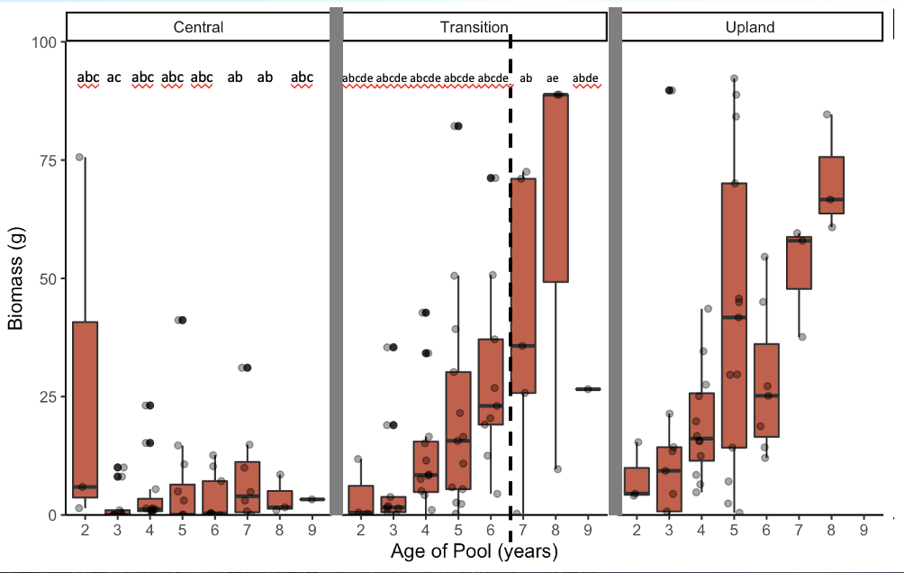

Figure 8. Total exotic species biomass in restored vernal pool zones over time. Boxplots show median and interquartile ranges. Letters show significant differences for post-hoc Tukey’s tests on generalized linear mixed effects model predictions (alpha = 0.1).

Table 5. ANOVA table of Exotic Biomass GLMER for multi-year monitoring experiment.

exotic_biomass_glmer <- full_join(annual_exotic_biomass, hydro) %>%

glmer((annual_biomass+1) ~ as.factor(Time_Since) + Replicate_Zone + as.factor(Time_Since):Replicate_Zone + (1|Year) + (1|depth) + (1|size) + (1|plot_replicate), family = Gamma(link = "log"), data = .)

|  |  |  |  |
| --- | --- | --- | --- |
|  | **(Exotic Biomass)** | | |
| *Predictors* | *Estimates* | *CI* | *p* |
| (Intercept) | 9.01 | 2.37 – 34.34 | **0.001** |
| pool age [3] | 0.18 | 0.06 – 0.54 | **0.002** |
| pool age [4] | 0.32 | 0.10 – 1.07 | 0.064 |
| pool age [5] | 0.52 | 0.14 – 2.00 | 0.341 |
| pool age [6] | 0.41 | 0.10 – 1.78 | 0.234 |
| pool age [7] | 1.07 | 0.23 – 5.11 | 0.928 |
| pool age [8] | 0.57 | 0.09 – 3.62 | 0.546 |
| pool age [9] | 0.84 | 0.08 – 8.51 | 0.880 |
| vegetation zone [transition] | 0.76 | 0.15 – 3.80 | 0.733 |
| vegetation zone [upland] | 2.46 | 0.49 – 12.25 | 0.271 |
| pool age [3] * vegetation zone [transition] | 4.84 | 1.09 – 21.44 | **0.038** |
| pool age [4] * vegetation zone [transition] | 6.12 | 1.29 – 28.99 | **0.023** |
| pool age [5] * vegetation zone [transition] | 4.23 | 0.76 – 23.50 | 0.098 |
| vegetation zone [transition] | 7.60 | 1.25 – 46.38 | **0.028** |
| pool age [7] * vegetation zone [transition] | 6.74 | 1.03 – 43.90 | **0.046** |
| pool age [8] * vegetation zone [transition] | 21.90 | 2.37 – 202.65 | **0.007** |
| pool age [9] * vegetation zone [transition] | 15.99 | 1.22 – 209.39 | **0.035** |
| pool age [3] * vegetation zone [upland] | 3.31 | 0.75 – 14.69 | 0.114 |
| pool age [4] * vegetation zone [upland] | 3.68 | 0.83 – 16.33 | 0.086 |
| pool age [5] * vegetation zone [upland] | 3.12 | 0.56 – 17.24 | 0.191 |
| pool age [6] * vegetation zone [upland] | 5.13 | 0.86 – 30.51 | 0.072 |
| pool age [7] * vegetation zone [upland] | 2.40 | 0.35 – 16.35 | 0.367 |
| pool age [8] * vegetation zone [upland] | 3.95 | 0.38 – 40.83 | 0.247 |
| pool age [9] * vegetation zone [upland] | 3.43 | 0.23 – 50.43 | 0.366 |
| **Random Effects** | | | |
| σ2 | 0.55 | | |
| τ00 quadrat | 0.62 | | |
| τ00 pool area | 0.00 | | |
| τ00 pool depth | 0.00 | | |
| τ00 monitoring year | 0.07 | | |
| ICC | 0.56 | | |
| N monitoring year | 3 | | |
| N pool depth | 6 | | |
| N pool area | 7 | | |
| N quadrat | 63 | | |
| Observations | 181 | | |
| Marginal R2 / Conditional R2 | 0.483 / 0.772 | | |

Native cover significantly decreased as pools aged, but only in the transition zone (*p* = 0.005; Figure 9). Post-hoc Tukey’s tests of generalized mixed effects model outputs indicate that, in the transition zone, exotic species cover significantly increased as the pools aged from 3 to 5 years old (*p* = 0.006; S4). In the upland zone, exotic species cover significantly increased as the pools aged from 4-5 years old (*p* = 0.0071; S4). There were no significant trends in the central or upland zones. Similarly, Shannon’s Index of Diversity for native species significantly decreased in the transition zone (*p* < 0.001; Figure 10), but there were no significant trends in the central or upland zones.

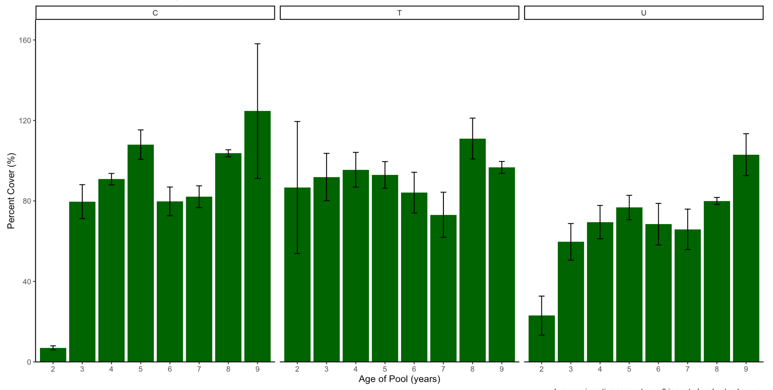

Figure 9. Total exotic species biomass in restored vernal pool zones over time. Boxplots show median and interquartile ranges. . Error bars represent +/-1SE from the mean.

Table 6. ANOVA table of Native Cover LMER for multi-year monitoring experiment.

native_pc_continuous_lmer <- np_annual_total_native %>%

lmer((max_annual_native_pc) ~ (Time_Since) + Replicate_Zone + Time_Since*Replicate_Zone + (1|Year) + (1|size) + (1|depth) + (1|plot_replicate), data = .)

|  |  |  |  |
| --- | --- | --- | --- |
|  | **(Native Percent Cover)** | | |
| *Predictors* | *Estimates* | *CI* | *p* |
| (Intercept) | 71.97 | 43.19 – 100.75 | **<0.001** |
| pool age | 2.97 | -1.57 – 7.51 | 0.199 |
| vegetation zone [transition] | 42.02 | 11.81 – 72.23 | **0.007** |
| vegetation zone [upland] | -13.56 | -43.78 – 16.65 | 0.377 |
| pool age * vegetation zone [transition] | -7.94 | -13.42 – -2.45 | **0.005** |
| pool age * vegetation zone [upland] | -1.19 | -6.68 – 4.29 | 0.668 |
| **Random Effects** | | | |
| σ2 | 425.96 | | |
| τ00 quadrat | 173.53 | | |
| τ00 pool area | 122.16 | | |
| τ00 pool depth | 250.77 | | |
| τ00 monitoring year | 0.00 | | |
| N monitoring year | 3 | | |
| N pool area | 7 | | |
| N pool depth | 6 | | |
| N quadrat | 63 | | |
| Observations | 189 | | |
| Marginal R2 / Conditional R2 | 0.234 / NA | | |

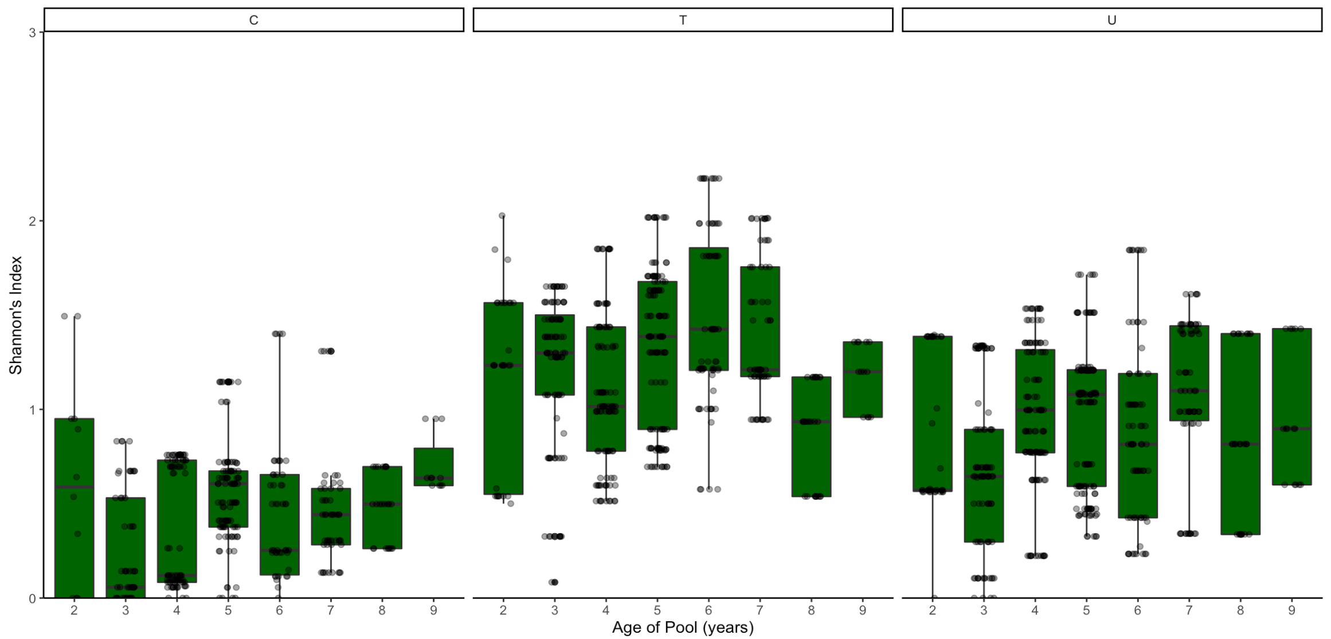

Figure 10. Shannon's Index of Diversity for native species in restored vernal pool zones over time. Boxplots show median and interquartile ranges.

Table 7. ANOVA table of Native Shannon’s Index of Diversity GLMER for multi-year monitoring experiment.

native_h_continuous_glmer <- glmer((max_native_h+1) ~ (Time_Since) + Replicate_Zone + (Time_Since):Replicate_Zone + (1|Year) + (1|plot_replicate), family = Gamma(link = "log"), max_annual_native_h)

|  |  |  |  |
| --- | --- | --- | --- |
|  | **(Shannon's Index of Diversity for Native Species)** | | |
| *Predictors* | *Estimates* | *CI* | *p* |
| (Intercept) | 1.21 | 1.03 – 1.43 | **0.024** |
| pool age | 1.04 | 1.01 – 1.07 | **0.012** |
| vegetation zone [transition] | 1.95 | 1.64 – 2.32 | **<0.001** |
| vegetation zone [upland] | 1.36 | 1.14 – 1.62 | **0.001** |
| pool age * vegetation zone [transition] | 0.95 | 0.93 – 0.97 | **<0.001** |
| pool age * vegetation zone [upland] | 0.99 | 0.97 – 1.01 | 0.385 |
| **Random Effects** | | | |
| σ2 | 0.02 | | |
| τ00 quadrat | 0.01 | | |
| τ00 pool area | 0.00 | | |
| τ00 pool depth | 0.00 | | |
| τ00 monitoring year | 0.00 | | |
| ICC | 0.27 | | |
| N Year | 4 | | |
| N pool area | 7 | | |
| N pool depth | 6 | | |
| N quadrat | 63 | | |
| Observations | 1455 | | |
| Marginal R2 / Conditional R2 | 0.520 / 0.651 | | |

**Discussion**

The increase in exotic cover in older pools in the chronosequence of vegetation dataset supports our H1.2 hypothesis that plant responses to abiotic and biotic conditions have a greater long-term effect than the legacy of restoration efforts. Although all pools attained <10% exotic cover and >90% native cover within the first five years of restoration implementation, these short-term successes did not translate into long-term successes. Exotic cover increased past 10%, and as high as 113.17% in the transition zone in pools 14 years and older (Figure 5). In the upland zone, exotic cover increased past 10%, and has high as 160.70%, in pools 8 years and older (Figure 5). Moreover, native cover was consistently <90% in the upland zone, and as low as 0% (Figure 6). Specifically, pools with shorter inundation periods had higher exotic cover, congruent with our hypothesis that longer inundation period provides abiotic resistance against generalist exotic annual grasses that cannot withstand flooding.

The most abundant exotic species were *Festuca perennis*, *Festuca bromoides*, *Festuca myuros*, *Polypogon monospeliensis*, *Erodium botrys*, *Bromus hordeaceus*, *Lythrum hyssopifolia*, and *Avena fatua*. Many of these grasses and low-growing forbs are listed by the California Invasive Plant Council as invasive species capable of out-competing native species and forming monocultures (California Invasive Plant Council 2022). To further corroborate the effect of the exotic assemblage on the native assemblage, we examined the Shannon’s Index of Diversity for native species and found that it significantly decreased in both transition and upland zones over time (Figure 7). Our results suggest that generalist grasses existing outside the restored pools are encroaching into the pools and displacing native species. This case study shows how short-term success can be misleading and that long-term monitoring is needed to determine success in the long run.

To better understand the cause of this vegetation shift over time, we coupled our chronosequence study with a multi-year monitoring study on a subset of younger created pools. The pools in this study were created and planted with native species within a grassland landscape. Intensive exotic species weeding continued for about 3-5 years after each pool was created, but then the pools phased into the maintenance phase and were only periodically hand-weeded or cleared with a weed-whacker. We again saw an increase in exotic plant cover and biomass over time in these created pools, supporting our H2.1 hypothesis that created pools are susceptible to invasion over time. Our analysis shows that the initial intensive exotic species weeding kept exotic cover low; however, after intensive weeding ceased as the pools aged to 5 years and older, exotic species cover and biomass increased in the transition and upland zones (Figs. 7-8). This also supports our H2.2 hypothesis that the edges of the pools suffer the most from being closest the invasion front and outside the central abiotic resistance zone afforded by prolonged inundation. Without continued dedicated weeding efforts, invasive grasses were able to repopulate themselves.

Interestingly, native cover and diversity in our multi-year monitoring experiment did not always decrease at the same time that exotic cover increased around year 5 (Figs. 9-10). However, this also highlights the importance of long-term monitoring. Although our multi-year study only encompassed pools as old as 9 years, our chronosequence dataset included pools as old as 30 years, and our results from that dataset show native cover decreasing significantly in pools 15 years and older (Figure 5). This suggests that, although some native species may be able to coexist with exotic species for a while, native species eventually get displaced. The Shannon’s Index of Diversity for native species in our chronosequence dataset showed native diversity decreasing in both the upland and transition zones (Figure 6). The dichotomy of the invaded transition and upland zones vs. the relatively uninvaded central zone may be explained by 1) exotic seeds blowing from the upland matrix into the transition zone, and 2) the abiotic filter of inundation in the center of the pool precluding invasion. If the upland grassland matrix is not included in the maintenance phase weeding, exotic species may proliferate and spread into restored vernal pools. Native species are still present in the all of the pools in this study, and wetland graminoids like *Eleocharis macrostachya*, *Eleocharis acicularis*, *Juncus mexicanus*, and *Juncus phaeocephalus* currently still dominate the central zones of the pools. Yet, many of these native species were planted in the transition and upland zones, which are now dominated by invasive graminoids. This further suggests that the invasive grasses are encroaching from the upland grassland into the pools themselves. Traditionally, strong abiotic filters associated with vernal pools, e.g., highly dynamic seasonal flooding and drying, preclude generalist exotics from invading into the pool centers (Bliss & Zedler 1998). However, increased drought due to climate change may be breaking down this abiotic filter. In drier conditions when the pools do not fill with water, grassland species are able to encroach through the center of the pool basin. This has been seen in local degraded vernal pools, with *Festuca perennis* dominating throughout the central, transition, and upland zones (Tang, *unpublished data*). Thus, Collinge and colleagues have emphasized the role of both abiotic and biotic filters (including human management) in creating and sustaining restored landscapes that are resistant to exotic invasion (Collinge, Ray & Gerhardt 2011; Gerhardt & Collinge 2009). Biotic filters that can decrease susceptibility to reinvasion include adaptive management strategies such as planting with competitive native species and removing exotic competitors through an array of long-term weed management strategies. For example, restoration projects may increase a vernal pool’s resistance to invasion by employing an array of invasive species management techniques in addition to short-term intensive weeding, such as bolstering the native seed bank and sourcing seed from competitive native ecotypes.

**Implications for Management**

Our case studies of long-term vegetation dynamics in restored vernal pools highlight the importance of continued maintenance and monitoring of restoration projects with the goal of identifying vulnerable portions of the landscape. During the implementation phase of restoration, native plants are installed and exotic plants are removed. However, the Society for Ecological Restoration (SER) identifies a post-implementation “maintenance phase” as an equally important part of the restoration process (Gann et al. 2019). During this maintenance phase, SER standards of practice recommend ongoing management and monitoring to ensure long-term success (Gann et al. 2019). The importance of monitoring can be seen by the long-term trends found in our data, with exotic cover increasing and native cover decreasing (Figs. 4-5). If monitoring had ceased three or four years post-restoration, site managers may have inaccurately assumed exotic species cover would remain low in the long run. However, the marked increase in exotic cover and biomass around year five changes the story of the restoration site (Figs. 7-8). This change can act as a trigger for adaptive management, e.g., if exotics continue to increase despite routine maintenance weeding, site managers can pivot their strategy and prioritize their resources on more large-scale weeding efforts. Long-term monitoring data are necessary for maintaining an adaptive management plan that can correct for rising exotic species.

Contrary to the Western perspective that short-term restoration projects should create self-sustaining restored ecosystems, our case studies suggest that long-term management is necessary to prevent invasion. Instead of viewing restoration projects primarily as short-term implementation efforts with auxiliary “maintenance phase”, the implementation phase of restoration should be viewed as an initiation of an ongoing restoration management plan. This directly aligns with indigenous land management practices, wherein humans are viewed as part of the annual and interannual dynamic of ecosystems (Anderson 2005). We suggest that “restoration” entails not only restoration of native plants and animals, but also the restoration of the symbiotic relationship between humans and nature via long-term human stewardship to create desirable ecosystems. Long-term adaptive management plans require ongoing monitoring so that management can pivot to address rising challenges. When funds are limited, engagement of local community groups to help with ongoing restoration efforts can achieve both ecological goals and social goals of engaging a diversity of people in maintaining biodiversity (Reyes 2011). Shifting our focus toward viewing restoration as a long-term relationship with the land may allow us to realize more resilient, resistant, and sustainable socioecological systems.

**Acknowledgements**

We thank CCBER for granting land access and staff time to conduct this project. We received field assistance, plant identification, and monitoring advice from Catherine Reilly, Wayne Chapman, Lisa Stratton, Ryan Clark, Darwin Richardson, Eirik De Wit, Lauren Weichart, Beau Tindall, Ryan Lippitt, Shaina Healey, Johnny Alonzo, Andy Lanes, Evan Hobson, Kelly Hildner, Jessica Nielsen, Kipp Callahan, Angela Rauhut, Valerie Olson, Branden Song, Jacquelyn Chau, Dan Shuman, Alice Wen, Keith Sibal, Abigail Boylan, Sam Desre, Michael Tucker, Thomas Nedungadan, Ana Camaddo, Emily Ramos, Nancy Clarin, and Justin Luong. Carla D’Antonio and Scott Cooper provided feedback on an early manuscript draft.

**References**

Anderson, M. K. (2005). Gathering, Hunting, and Fishing. In *Tending the Wild*. University of California Press.

Aradottir, A. L., & Hagen, D. (2013). Ecological restoration: approaches and impacts on vegetation, soils and society. In *Advances in Agronomy* (Vol. 120, pp. 173-222). Academic Press.

Black, C., & Zedler, P. H. (1998). An overview of 15 years of vernal pool restoration and construction activities in San Diego County, California. In *Ecology, Conservation and Management of Vernal Pool Ecosystems–Proceedings from a 1996 Conference. California Native Plant Society, Sacramento, CA* (pp. 195-205).

California Invasive Plant Council. (n.d.). *The Cal-IPC Inventory*. California Invasive Plant Council. Retrieved January 9, 2022, from https://www.cal-ipc.org/plants/inventory/

Collinge, S. K., Ray, C., & Gerhardt, F. (2011). Long‐term dynamics of biotic and abiotic resistance to exotic species invasion in restored vernal pool plant communities. *Ecological Applications*, *21*(6), 2105-2118.

Davies, K. W. (2011). Plant community diversity and native plant abundance decline with increasing abundance of an exotic annual grass. *Oecologia*, *167*(2), 481-491.

Faist, A. M., & Beals, S. C. (2018). Invasive plant feedbacks promote alternative states in California vernal pools. *Restoration Ecology*, *26*(2), 255-263.

Gann, G. D., McDonald, T., Walder, B., Aronson, J., Nelson, C. R., Jonson, J., ... & Dixon, K. W. (2019). International principles and standards for the practice of ecological restoration. *Restoration Ecology, 27*(S1), S1-S46.

Gerhardt, F., & Collinge, S. K. (2007). Abiotic constraints eclipse biotic resistance in determining invasibility along experimental vernal pool gradients. *Ecological Applications*, *17*(3), 922-933.

Gutrich, J. J., Taylor, K. J., & Fennessy, M. S. (2009). Restoration of vegetation communities of created depressional marshes in Ohio and Colorado (USA): the importance of initial effort for mitigation success. *Ecological Engineering*, *35*(3), 351-368.

Mitsch, W. J., & Wilson, R. F. (1996). Improving the success of wetland creation and restoration with know‐how, time, and self‐design. *Ecological Applications*, *6*(1), 77-83.

Mooney, H., & Zavaleta, E. (2016). *Ecosystems of California*. Univ of California Press.

Nilsson, C., Aradottir, A. L., Hagen, D., Halldórsson, G., Høegh, K., Mitchell, R. J., ... & Wilson, S. D. (2016). Evaluating the process of ecological restoration. *Ecology and Society*, *21*(1).

Norton, J. B., Monaco, T. A., & Norton, U. (2007). Mediterranean annual grasses in western North America: kids in a candy store. *Plant and Soil*, *298*(1), 1-5.

Reyes, J. E. (2011). Public participation and socioecological resilience. In D. Egan, E. Hjerpe, J. Abrams (Eds.). *Human Dimensions of Ecological Restoration: Integrating Science, Nature, and Culture* (pp. 79-92). Island Press, Washington, DC.

Soil Survey Staff, Natural Resources Conservation Service, United States Department of Agriculture. Web Soil Survey. Available online at the following link: <http://websoilsurvey.sc.egov.usda.gov/>. Accessed 2/7/2022.

Valliere, J. M., Irvine, I. C., Santiago, L., & Allen, E. B. (2017). High N, dry: experimental nitrogen deposition exacerbates native shrub loss and nonnative plant invasion during extreme drought. *Global Change Biology*, *23*(10), 4333-4345.

Zedler, P. H. (1987). *The ecology of southern California vernal pools: a community profile* (Vol. 85, No. 7). Fish and Wildlife Service, US Department of the Interior.

**Appendix 1.**

*Restoration Actions for Focal Vernal Pools in Multi-Year Monitoring Experiment*

All vernal pool restoration was conducted by the Cheadle Center for Biodiversity and Ecological Restoration at UCSB (CCBER; https://ccber.ucsb.edu). We monitored 7 restored vernal pools within the management unit named North Parcel (Figure 1). The pools were created between 2011 and 2014, and varied in size and depth (Table 1), but all 7 pools were managed in a similar fashion.

Restoration of the vernal pools began by grading to deepen vernal pool basins. As vernal pools were constructed with adjacent upland area to facilitate soil restoration, sifted compost from the Santa Barbara County was distributed throughout the area at approximately 6 inches in depth. A tractor tilled the compost into dry soil to a depth of approximately 8-12 inches. No organic material was incorporated into the wetland basins. Additionally, a humate product called Live Earth Soil Conditioner (1.50% sulfur, 2.25% iron, 45% humic acid) and Live Earth First Green (4% calcium, 5% sulfur, 1% iron, and 5% nitrogen, 3% phosphorous, and 1% potassium) was equally distributed one time, across both wetland and upland soils, at a depth of approximately 5 inches (need amount).

After the site was physically manipulated and amended, the individual pools were planted, and to a lesser degree seeded, with approximately 140 species of locally-sourced native plants from vernal pool, vernal marsh, coastal prairie, and coastal sage scrub assemblages. Vegetation was purposely planted in patches to mimic landscape patterns generally observed in nature, according to soil types, hydrology, and other site factors. Planting continued throughout the summer months in some cases. Installed plantings were watered-in using mainly moveable drip irrigation until establishment was achieved.

After the initial planting was completed, the site was actively maintained in a number of ways. First, native annual thatch was periodically removed in the late summer and fall months, to simulate clearing likely done by historically indigenous burning practices. Species whose thatch was removed include *Centromadia parryi* ssp. *australis*, *Simphyotrichium sublatum*, *Dienandra fasciculata*. Thatch material from perennial natives, such as *Stipa pulchra*, was also removed annually in places for the same effect. Additionally, certain native species are removed periodically to maintain landscape variability, facilitate the colonization of novel or desirable native species, and avoid homogenization of common species such as *Baccharis pilularis*, *Typha* spp., *Schoenoplectus californicus*, and *Salix* spp. Exotic species were controlled mainly by hand-weeding, although solarization, herbicide, and green flaming were also employed to a lesser degree. This implementation phase of this restoration project lasted 5 years.

**Supplemental Figures**

S1. Ages and sizes of monitored vernal pools.

|  |  |  |  |
| --- | --- | --- | --- |
| **Restoration Site** | **Vernal Pool ID** | **Creation Year** | **Area (square meters)** |
| Camino Corto Open Space | 2 | 1997 | 578.25149 |
| 3 | 1997 | 282.98003 |
| 4 | 1997 | 215.82577 |
| 5 | 1997 | 205.04528 |
| 6 | 1997 | 841.86376 |
| 7 | 1997 | 1297.04083 |
| 8 | 1997 | 115.48721 |
| Del Sol Vernal Pool Preserve | E | 1986 | 1461.22026 |
| F | 1991 | 196.49584 |
| G | 1986 | 420.91006 |
| H | 1986 | 66.97073 |
| M | 1986 | 74.00052 |
| N | 1986 | 1267.18599 |
| S | 1997 | 571.45015 |
| T | 1997 | 158.80983 |
| U | 1997 | 444.76421 |
| V | 1997 | 945.26530 |
| W | 1986 | 964.58172 |
| Ellwood Mesa Open Pace | 1 | 1980 | 473.09113 |
| 2 | 1980 | 185.55477 |
| 3 | 1980 | 202.30872 |
| 4 | 1980 | 64.95253 |
| 5 | 1980 | 214.93384 |
| Manzanita Village | San Miguel | 2002 | 279.81479 |
| Santa Barbara | 2002 | 195.94477 |
| Santa Catalina | 2002 | 186.90141 |
| Santa Cruz | 2002 | 129.53654 |
| Santa Rosa | 2002 | 272.70344 |
| North Campus Open Space | 1 | 2017 | 1367.09233 |
| 2 | 2017 | 544.07430 |
| 3 | 2017 | 1081.28057 |
| 4 | 2017 | 669.13452 |
| 5 | 2017 | 362.43625 |
| 6 | 2017 | 355.67991 |
| 7 | 2017 | 540.88420 |
| 8 | 2017 | 247.33571 |
| North Parcel | 14 | 2014 | 432.89275 |
| 16 | 2014 | 424.18353 |
| 19 | 2013 | 359.35838 |
| 3 | 2012 | 67.80549 |
| 4 | 2012 | 85.28026 |
| 6 | 2012 | 79.45495 |
| 7 | 2012 | 346.78561 |
| 9 | 2015 | 160.07318 |
| PH1 | 2010 | 173.12680 |
| Sierra Madre | Central Wetland | 2015 | 678.64330 |
| South Parcel | 1 | 2011 | 322.58988 |
| 2 | 2011 | 330.63380 |
| 3 | 2011 | 366.71542 |
| 4 | 2011 | 172.63579 |
| 5 | 2011 | 283.08781 |
| 6 | 2011 | 245.20166 |
| 7 | 2011 | 532.95060 |
| 8 | 2011 | 139.53243 |
| 9 | 2011 | 78.35054 |
| SWW 1 | 2011 | 344.68195 |
| Storke Ranch | 2007 | 2007 | 66.98034 |
| 2017 | 2017 | 68.58075 |
| East | 2006 | 379.64773 |
| North | 2006 | 306.16317 |
| South | 2006 | 233.48607 |
| West Campus Bluffs | 1 | 2019 | 838.63646 |
| 10 | 2002 | 98.54318 |
| 11 | 2002 | 105.14194 |
| 13 | 2002 | 56.54870 |
| 4 | 1997 | 1017.73074 |
| 6 | 1997 | 237.47864 |
| 8 | 2002 | 114.68265 |
| 9 | 2002 | 341.98304 |

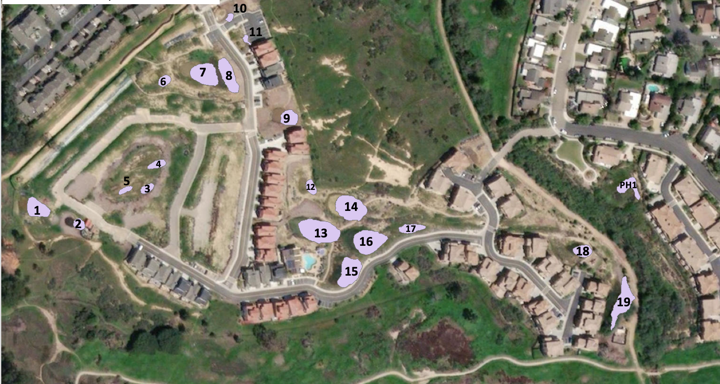

S2. North Parcel vernal pools. #3, 7, 9, 14, 16, 19, & PH1 monitored in this study.

S3. Full species list of species found throughout pools. Species denoted with an asterisk were planted by CCBER.

|  |  |
| --- | --- |
| **Species** | **Native Status (Native = N, Exotic = E)** |
| *Acmispon glaber\** | N |
| *Acmispon species* | E |
| *Alisma lanceolatum* | E |
| *Alopecurus saccatus\** | N |
| *Ambrosia psilostachya* | N |
| *Anemopsis californica\** | N |
| *Artemisia californica\** | N |
| *Artemisia douglasiana\** | N |
| *Asclepias fascicularis\** | N |
| *Atriplex californica\** | N |
| *Atriplex lentiformis\** | N |
| *Atriplex semibaccata* | E |
| *Baccharis douglasii\** | N |
| *Baccharis pilularis* | N |
| *Baccharis plummerae\** | N |
| *Baccharis salicifolia\** | N |
| *Bolboschoenus maritimus* | N |
| *Brachypodium distachyon* | E |
| *Brassica nigra* | E |
| *Bromus carinatus\** | N |
| *Bromus diandrus* | E |
| *Bromus hordeaceus* | E |
| *Bromus madritensis* | E |
| *Calystegia macrostegia* | N |
| *Carduus pycnocephalus* | E |
| *Carex praegracilis* | N |
| *Centaurium tenuiflorum* | E |
| *Centromadia parryi ssp. australis* | N |
| *Corethrogyne filaginifolia* | N |
| *Cotula coronopifolia* | E |
| *Crassula aquatica* | N |
| *Cressa truxillensis* | N |
| *Croton setigerus* | N |
| *Crypsis schoenoides* | E |
| *Cyperus eragrostis* | N |
| *Deinandra fasciculata* | N |
| *Diplacus aurantiacus\** | N |
| *Distichlis spicata\** | N |
| *Eleocharis acicularis\** | N |
| *Eleocharis machrostachya\** | N |
| *Elymus condensatus\** | N |
| *Elymus glaucus\** | N |
| *Elymus triticoides\** | N |
| *Encelia californica\** | N |
| *Epilobium brachycarphum* | N |
| *Epilobium canum\** | N |
| *Erigeron bonariensis* | E |
| *Erigeron canadensis* | N |
| *Erigeron sumatrensis* | E |
| *Eriogonum parvifolium\** | N |
| *Eriophyllum confertiflorum\** | N |
| *Erodium cicutarium* | E |
| *Eryngium armatum\** | N |
| *Eryngium vaseyi\** | N |
| *Eschscholzia californica\** | N |
| *Euphorbia peplus* | E |
| *Euphorbia serpens* | E |
| *Extriplex californica* | N |
| *Festuca myuros* | E |
| *Festuca perennis* | E |
| *Foeniculum vulgare* | E |
| *Frankenia salina\** | N |
| *Geranium dissectum* | E |
| *Grindelia camporum* | N |
| *Hazardia squarrosa\** | N |
| *Helminthotheca echiodes* | E |
| *Heteromeles arbutifolia\** | N |
| *Heterotheca grandifolia* | N |
| *Hordeum brachyantherum\** | N |
| *Hordeum murinum* | E |
| *Hypochaeris glabra* | E |
| *Isocoma menziesii* | N |
| *Isolepis cernua* | N |
| *Jaumea carnosa\** | N |
| *Juncus acutus\** | N |
| *Juncus bufonius\** | N |
| *Juncus mexicanus\** | N |
| *Juncus occidentalis\** | N |
| *Juncus patens\** | N |
| *Juncus phaeocephalus\** | N |
| *Juncus textilis\** | N |
| *Lactuca serriola* | E |
| *Laennecia coulteri* | N |
| *Lepidium nitidum* | N |
| *Logfia gallica* | E |
| *Lonicera subspicata\** | N |
| *Lupinus microcarpus* | N |
| *Lupinus succulentus* | N |
| *Lysimachia arvensis* | E |
| *Lythrum hyssopifolia* | E |
| *Malacothrix saxatilis\** | N |
| *Malva parviflora* | E |
| *Malvella leprosa* | N |
| *Medicago lupulina* | E |
| *Medicago polymorpha* | E |
| *Melilotus indicus* | E |
| *Melilotus species* | E |
| *Monanthechloe littoralis\** | N |
| *Oxalis californica* | N |
| *Paraphalis incurva* | E |
| *Phalaris lemmonii\** | N |
| *Plagiobothrys undulatus\** | N |
| *Platanus racemose* | N |
| *Plantago coronopus* | E |
| *Plantago lanceolata* | E |
| *Poa annua* | E |
| *Polycarpon tetraphyllum* | E |
| *Polygonum aviculare ssp.depressum* | E |
| *Polypogon interruptus* | E |
| *Polypogon monospeliensis* | E |
| *Pseudognaphalium californicum\** | N |
| *Pseudognaphalium canescens\** | N |
| *Pseudognaphalium luteoalbum* | E |
| *Psilocarphus brevissimus\** | N |
| *Quercus agrifolia\** | N |
| *Raphanus sativus* | E |
| *Rhamnus californica\** | N |
| *Rhus integrifolia\** | N |
| *Ribes speciosum\** | N |
| *Rosa californica\** | N |
| *Rumex crispus* | E |
| *Rumex salicifolius\** | N |
| *Salsola tragus* | E |
| *Salvia mellifera\** | N |
| *Salvia leucophylla\** | N |
| *Salvia spathacea\** | N |
| *Sambucus mexicana\** | N |
| *Schoenoplectus americanus\** | N |
| *Schoenoplectus californicus\** | N |
| *Schoenoplectus pungens\** | N |
| *Scrophularia californica\** | N |
| *Senecio vulgaris* | E |
| *Sisyrinchium bellum\** | N |
| *Solanum douglasii\** | N |
| *Sonchus asper* | E |
| *Sonchus oleraceus* | E |
| *Spergularia species* | E |
| *Stipa pulchra\** | N |
| *Symphoricarpos mollis\** | N |
| *Symphyotrichum chilense\** | N |
| *Symphyotrichum subulatum* | N |
| *Taraxacum officinale* | E |
| *Trifolium hirtum* | E |
| *Typha domingensis* | N |
| *Verbena lasiostachys\** | N |
| *Vicia sativa* | E |
| *Vicia villosa* | E |
| *Zeltnera muehlenbergii\** | N |

S4. Post-hoc Tukey’s results for exotic percent cover GLMER generated from multi-year monitoring data.

|  |  |  |  |
| --- | --- | --- | --- |
| Central Zone |  |  |  |
| contrast estimate SE df z.ratio p.value | | | |
| 2 - 3 0.81886 0.498 Inf 1.643 0.7239 | | | |
| 2 - 4 0.86742 0.493 Inf 1.759 0.6481 | | | |
| 2 - 5 0.81618 0.545 Inf 1.499 0.8085 | | | |
| 2 - 6 0.67774 0.568 Inf 1.192 0.9344 | | | |
| 2 - 7 0.51696 0.619 Inf 0.835 0.9911 | | | |
| 2 - 8 0.08345 0.627 Inf 0.133 1.0000 | | | |
| 2 - 9 0.76070 0.957 Inf 0.795 0.9934 | | | |
| 3 - 4 0.04856 0.460 Inf 0.106 1.0000 | | | |
| 3 - 5 -0.00268 0.509 Inf -0.005 1.0000 | | | |
| 3 - 6 -0.14112 0.538 Inf -0.262 1.0000 | | | |
| 3 - 7 -0.30190 0.591 Inf -0.511 0.9996 | | | |
| 3 - 8 -0.73541 0.603 Inf -1.220 0.9262 | | | |
| 3 - 9 -0.05816 0.940 Inf -0.062 1.0000 | | | |
| 4 - 5 -0.05124 0.397 Inf -0.129 1.0000 | | | |
| 4 - 6 -0.18969 0.434 Inf -0.437 0.9999 | | | |
| 4 - 7 -0.35046 0.503 Inf -0.697 0.9971 | | | |
| 4 - 8 -0.78397 0.539 Inf -1.453 0.8321 | | | |
| 4 - 9 -0.10673 0.890 Inf -0.120 1.0000 | | | |
| 5 - 6 -0.13845 0.404 Inf -0.343 1.0000 | | | |
| 5 - 7 -0.29922 0.492 Inf -0.608 0.9988 | | | |
| 5 - 8 -0.73273 0.556 Inf -1.317 0.8927 | | | |
| 5 - 9 -0.05549 0.889 Inf -0.062 1.0000 | | | |
| 6 - 7 -0.16077 0.456 Inf -0.353 1.0000 | | | |
| 6 - 8 -0.59429 0.573 Inf -1.037 0.9689 | | | |
| 6 - 9 0.08296 0.889 Inf 0.093 1.0000 | | | |
| 7 - 8 -0.43351 0.617 Inf -0.703 0.9969 | | | |
| 7 - 9 0.24373 0.902 Inf 0.270 1.0000 | | | |
| 8 - 9 0.67725 0.866 Inf 0.782 0.9940 | | | |

|  |  |  |  |
| --- | --- | --- | --- |
| Transition Zone |  |  |  |
| contrast estimate SE df z.ratio p.value | | | |
| 2 - 3 0.90877 0.433 Inf 2.101 0.4143 | | | |
| 2 - 4 0.22585 0.423 Inf 0.534 0.9995 | | | |
| 2 - 5 -0.44604 0.450 Inf -0.992 0.9757 | | | |
| 2 - 6 -0.66823 0.483 Inf -1.384 0.8651 | | | |
| 2 - 7 -0.95981 0.527 Inf -1.820 0.6064 | | | |
| 2 - 8 -1.69743 0.584 Inf -2.907 0.0712 | | | |
| 2 - 9 -1.50799 0.656 Inf -2.300 0.2935 | | | |
| 3 - 4 -0.68292 0.310 Inf -2.200 0.3517 | | | |
| 3 - 5 -1.35480 0.321 Inf -4.225 0.0006 | | | |
| 3 - 6 -1.57700 0.368 Inf -4.280 0.0005 | | | |
| 3 - 7 -1.86858 0.420 Inf -4.444 0.0002 | | | |
| 3 - 8 -2.60620 0.493 Inf -5.292 <.0001 | | | |
| 3 - 9 -2.41676 0.569 Inf -4.246 0.0006 | | | |
| 4 - 5 -0.67189 0.249 Inf -2.693 0.1245 | | | |
| 4 - 6 -0.89408 0.296 Inf -3.022 0.0513 | | | |
| 4 - 7 -1.18566 0.342 Inf -3.464 0.0125 | | | |
| 4 - 8 -1.92328 0.437 Inf -4.403 0.0003 | | | |
| 4 - 9 -1.73384 0.500 Inf -3.469 0.0122 | | | |
| 5 - 6 -0.22219 0.236 Inf -0.942 0.9819 | | | |
| 5 - 7 -0.51377 0.262 Inf -1.964 0.5067 | | | |
| 5 - 8 -1.25140 0.406 Inf -3.085 0.0426 | | | |
| 5 - 9 -1.06195 0.448 Inf -2.369 0.2565 | | | |
| 6 - 7 -0.29158 0.269 Inf -1.083 0.9605 | | | |
| 6 - 8 -1.02920 0.411 Inf -2.505 0.1933 | | | |
| 6 - 9 -0.83976 0.456 Inf -1.842 0.5909 | | | |
| 7 - 8 -0.73763 0.392 Inf -1.883 0.5628 | | | |
| 7 - 9 -0.54818 0.381 Inf -1.437 0.8400 | | | |
| 8 - 9 0.18944 0.420 Inf 0.451 0.9998 | | | |
| Upland Zone |  |  |  |
| contrast estimate SE df z.ratio p.value | | | |
| 2 - 3 0.15432 0.440 Inf 0.351 1.0000 | | | |
| 2 - 4 -0.21262 0.441 Inf -0.482 0.9997 | | | |
| 2 - 5 -1.06518 0.471 Inf -2.264 0.3139 | | | |
| 2 - 6 -1.24390 0.508 Inf -2.451 0.2170 | | | |
| 2 - 7 -1.63658 0.542 Inf -3.018 0.0519 | | | |
| 2 - 8 -1.69556 0.596 Inf -2.847 0.0837 | | | |
| 2 - 9 -1.90874 0.670 Inf -2.847 0.0838 | | | |
| 3 - 4 -0.36694 0.272 Inf -1.348 0.8803 | | | |
| 3 - 5 -1.21950 0.293 Inf -4.162 0.0008 | | | |
| 3 - 6 -1.39822 0.354 Inf -3.955 0.0020 | | | |
| 3 - 7 -1.79090 0.399 Inf -4.493 0.0002 | | | |
| 3 - 8 -1.84988 0.469 Inf -3.941 0.0021 | | | |
| 3 - 9 -2.06306 0.555 Inf -3.718 0.0049 | | | |
| 4 - 5 -0.85256 0.235 Inf -3.623 0.0071 | | | |
| 4 - 6 -1.03127 0.286 Inf -3.609 0.0074 | | | |
| 4 - 7 -1.42396 0.334 Inf -4.268 0.0005 | | | |
| 4 - 8 -1.48294 0.418 Inf -3.550 0.0092 | | | |
| 4 - 9 -1.69612 0.493 Inf -3.440 0.0135 | | | |
| 5 - 6 -0.17872 0.229 Inf -0.779 0.9942 | | | |
| 5 - 7 -0.57140 0.250 Inf -2.286 0.3010 | | | |
| 5 - 8 -0.63038 0.381 Inf -1.653 0.7174 | | | |
| 5 - 9 -0.84356 0.427 Inf -1.974 0.4999 | | | |
| 6 - 7 -0.39268 0.260 Inf -1.507 0.8038 | | | |
| 6 - 8 -0.45166 0.385 Inf -1.175 0.9393 | | | |
| 6 - 9 -0.66485 0.429 Inf -1.550 0.7800 | | | |
| 7 - 8 -0.05898 0.352 Inf -0.168 1.0000 | | | |
| 7 - 9 -0.27216 0.351 Inf -0.775 0.9944 | | | |
| 8 - 9 -0.21318 0.405 Inf -0.526 0.9995 | | | |

S5. Post-hoc Tukey’s results for biomass GLMER generated from multi-year monitoring data.

Replicate_Zone = C:

contrast estimate SE df t.ratio p.value

2 - 3 -72.667 18.1 165 -4.019 0.0022

2 - 4 -83.833 17.5 165 -4.788 0.0001

2 - 5 -101.000 17.2 165 -5.888 <.0001

2 - 6 -72.778 18.1 165 -4.025 0.0022

2 - 7 -75.111 18.1 165 -4.154 0.0013

2 - 8 -96.667 22.1 165 -4.365 0.0006

2 - 9 -117.667 22.1 165 -5.313 <.0001

3 - 4 -11.167 12.0 165 -0.934 0.9823

3 - 5 -28.333 11.4 165 -2.477 0.2125

3 - 6 -0.111 12.8 165 -0.009 1.0000

3 - 7 -2.444 12.8 165 -0.191 1.0000

3 - 8 -24.000 18.1 165 -1.327 0.8873

3 - 9 -45.000 18.1 165 -2.489 0.2077

4 - 5 -17.167 10.5 165 -1.634 0.7290

4 - 6 11.056 12.0 165 0.924 0.9833

4 - 7 8.722 12.0 165 0.729 0.9960

4 - 8 -12.833 17.5 165 -0.733 0.9959

4 - 9 -33.833 17.5 165 -1.932 0.5308

5 - 6 28.222 11.4 165 2.468 0.2168

5 - 7 25.889 11.4 165 2.264 0.3201

5 - 8 4.333 17.2 165 0.253 1.0000

5 - 9 -16.667 17.2 165 -0.972 0.9778

6 - 7 -2.333 12.8 165 -0.182 1.0000

6 - 8 -23.889 18.1 165 -1.321 0.8897

6 - 9 -44.889 18.1 165 -2.482 0.2104

7 - 8 -21.556 18.1 165 -1.192 0.9332

7 - 9 -42.556 18.1 165 -2.353 0.2717

8 - 9 -21.000 22.1 165 -0.948 0.9807

Replicate_Zone = T:

contrast estimate SE df t.ratio p.value

2 - 3 -5.222 18.1 165 -0.289 1.0000

2 - 4 -8.833 17.5 165 -0.505 0.9996

2 - 5 -6.267 17.2 165 -0.365 1.0000

2 - 6 2.556 18.1 165 0.141 1.0000

2 - 7 13.556 18.1 165 0.750 0.9952

2 - 8 -24.333 22.1 165 -1.099 0.9563

2 - 9 -10.000 22.1 165 -0.452 0.9998

3 - 4 -3.611 12.0 165 -0.302 1.0000

3 - 5 -1.044 11.4 165 -0.091 1.0000

3 - 6 7.778 12.8 165 0.608 0.9987

3 - 7 18.778 12.8 165 1.469 0.8230

3 - 8 -19.111 18.1 165 -1.057 0.9646

3 - 9 -4.778 18.1 165 -0.264 1.0000

4 - 5 2.567 10.5 165 0.244 1.0000

4 - 6 11.389 12.0 165 0.952 0.9802

4 - 7 22.389 12.0 165 1.872 0.5721

4 - 8 -15.500 17.5 165 -0.885 0.9870

4 - 9 -1.167 17.5 165 -0.067 1.0000

5 - 6 8.822 11.4 165 0.771 0.9943

5 - 7 19.822 11.4 165 1.733 0.6656

5 - 8 -18.067 17.2 165 -1.053 0.9652

5 - 9 -3.733 17.2 165 -0.218 1.0000

6 - 7 11.000 12.8 165 0.860 0.9890

6 - 8 -26.889 18.1 165 -1.487 0.8134

6 - 9 -12.556 18.1 165 -0.694 0.9971

7 - 8 -37.889 18.1 165 -2.095 0.4223

7 - 9 -23.556 18.1 165 -1.303 0.8968

8 - 9 14.333 22.1 165 0.647 0.9981

Replicate_Zone = U:

contrast estimate SE df t.ratio p.value

2 - 3 -36.667 18.1 165 -2.028 0.4666

2 - 4 -46.500 17.5 165 -2.656 0.1440

2 - 5 -53.733 17.2 165 -3.132 0.0419

2 - 6 -45.444 18.1 165 -2.513 0.1973

2 - 7 -42.889 18.1 165 -2.372 0.2623

2 - 8 -57.000 22.1 165 -2.574 0.1732

2 - 9 -80.000 22.1 165 -3.612 0.0094

3 - 4 -9.833 12.0 165 -0.822 0.9917

3 - 5 -17.067 11.4 165 -1.492 0.8106

3 - 6 -8.778 12.8 165 -0.686 0.9973

3 - 7 -6.222 12.8 165 -0.487 0.9997

3 - 8 -20.333 18.1 165 -1.124 0.9506

3 - 9 -43.333 18.1 165 -2.396 0.2501

4 - 5 -7.233 10.5 165 -0.689 0.9972

4 - 6 1.056 12.0 165 0.088 1.0000

4 - 7 3.611 12.0 165 0.302 1.0000

4 - 8 -10.500 17.5 165 -0.600 0.9988

4 - 9 -33.500 17.5 165 -1.913 0.5438

5 - 6 8.289 11.4 165 0.725 0.9961

5 - 7 10.844 11.4 165 0.948 0.9807

5 - 8 -3.267 17.2 165 -0.190 1.0000

5 - 9 -26.267 17.2 165 -1.531 0.7895

6 - 7 2.556 12.8 165 0.200 1.0000

6 - 8 -11.556 18.1 165 -0.639 0.9983

6 - 9 -34.556 18.1 165 -1.911 0.5454

7 - 8 -14.111 18.1 165 -0.780 0.9939

7 - 9 -37.111 18.1 165 -2.052 0.4503

8 - 9 -23.000 22.1 165 -1.039 0.9678

S6. Post-hoc Tukey’s results for native cover LMER generated from multi-year monitoring data.

Replicate_Zone = C:

contrast estimate SE df t.ratio p.value

2 - 3 -72.667 18.1 165 -4.019 0.0022

2 - 4 -83.833 17.5 165 -4.788 0.0001

2 - 5 -101.000 17.2 165 -5.888 <.0001

2 - 6 -72.778 18.1 165 -4.025 0.0022

2 - 7 -75.111 18.1 165 -4.154 0.0013

2 - 8 -96.667 22.1 165 -4.365 0.0006

2 - 9 -117.667 22.1 165 -5.313 <.0001

3 - 4 -11.167 12.0 165 -0.934 0.9823

3 - 5 -28.333 11.4 165 -2.477 0.2125

3 - 6 -0.111 12.8 165 -0.009 1.0000

3 - 7 -2.444 12.8 165 -0.191 1.0000

3 - 8 -24.000 18.1 165 -1.327 0.8873

3 - 9 -45.000 18.1 165 -2.489 0.2077

4 - 5 -17.167 10.5 165 -1.634 0.7290

4 - 6 11.056 12.0 165 0.924 0.9833

4 - 7 8.722 12.0 165 0.729 0.9960

4 - 8 -12.833 17.5 165 -0.733 0.9959

4 - 9 -33.833 17.5 165 -1.932 0.5308

5 - 6 28.222 11.4 165 2.468 0.2168

5 - 7 25.889 11.4 165 2.264 0.3201

5 - 8 4.333 17.2 165 0.253 1.0000

5 - 9 -16.667 17.2 165 -0.972 0.9778

6 - 7 -2.333 12.8 165 -0.182 1.0000

6 - 8 -23.889 18.1 165 -1.321 0.8897

6 - 9 -44.889 18.1 165 -2.482 0.2104

7 - 8 -21.556 18.1 165 -1.192 0.9332

7 - 9 -42.556 18.1 165 -2.353 0.2717

8 - 9 -21.000 22.1 165 -0.948 0.9807

Replicate_Zone = T:

contrast estimate SE df t.ratio p.value

2 - 3 -5.222 18.1 165 -0.289 1.0000

2 - 4 -8.833 17.5 165 -0.505 0.9996

2 - 5 -6.267 17.2 165 -0.365 1.0000

2 - 6 2.556 18.1 165 0.141 1.0000

2 - 7 13.556 18.1 165 0.750 0.9952

2 - 8 -24.333 22.1 165 -1.099 0.9563

2 - 9 -10.000 22.1 165 -0.452 0.9998

3 - 4 -3.611 12.0 165 -0.302 1.0000

3 - 5 -1.044 11.4 165 -0.091 1.0000

3 - 6 7.778 12.8 165 0.608 0.9987

3 - 7 18.778 12.8 165 1.469 0.8230

3 - 8 -19.111 18.1 165 -1.057 0.9646

3 - 9 -4.778 18.1 165 -0.264 1.0000

4 - 5 2.567 10.5 165 0.244 1.0000

4 - 6 11.389 12.0 165 0.952 0.9802

4 - 7 22.389 12.0 165 1.872 0.5721

4 - 8 -15.500 17.5 165 -0.885 0.9870

4 - 9 -1.167 17.5 165 -0.067 1.0000

5 - 6 8.822 11.4 165 0.771 0.9943

5 - 7 19.822 11.4 165 1.733 0.6656

5 - 8 -18.067 17.2 165 -1.053 0.9652

5 - 9 -3.733 17.2 165 -0.218 1.0000

6 - 7 11.000 12.8 165 0.860 0.9890

6 - 8 -26.889 18.1 165 -1.487 0.8134

6 - 9 -12.556 18.1 165 -0.694 0.9971

7 - 8 -37.889 18.1 165 -2.095 0.4223

7 - 9 -23.556 18.1 165 -1.303 0.8968

8 - 9 14.333 22.1 165 0.647 0.9981

Replicate_Zone = U:

contrast estimate SE df t.ratio p.value

2 - 3 -36.667 18.1 165 -2.028 0.4666

2 - 4 -46.500 17.5 165 -2.656 0.1440

2 - 5 -53.733 17.2 165 -3.132 0.0419

2 - 6 -45.444 18.1 165 -2.513 0.1973

2 - 7 -42.889 18.1 165 -2.372 0.2623

2 - 8 -57.000 22.1 165 -2.574 0.1732

2 - 9 -80.000 22.1 165 -3.612 0.0094

3 - 4 -9.833 12.0 165 -0.822 0.9917

3 - 5 -17.067 11.4 165 -1.492 0.8106

3 - 6 -8.778 12.8 165 -0.686 0.9973

3 - 7 -6.222 12.8 165 -0.487 0.9997

3 - 8 -20.333 18.1 165 -1.124 0.9506

3 - 9 -43.333 18.1 165 -2.396 0.2501

4 - 5 -7.233 10.5 165 -0.689 0.9972

4 - 6 1.056 12.0 165 0.088 1.0000

4 - 7 3.611 12.0 165 0.302 1.0000

4 - 8 -10.500 17.5 165 -0.600 0.9988

4 - 9 -33.500 17.5 165 -1.913 0.5438

5 - 6 8.289 11.4 165 0.725 0.9961

5 - 7 10.844 11.4 165 0.948 0.9807

5 - 8 -3.267 17.2 165 -0.190 1.0000

5 - 9 -26.267 17.2 165 -1.531 0.7895

6 - 7 2.556 12.8 165 0.200 1.0000

6 - 8 -11.556 18.1 165 -0.639 0.9983

6 - 9 -34.556 18.1 165 -1.911 0.5454

7 - 8 -14.111 18.1 165 -0.780 0.9939

7 - 9 -37.111 18.1 165 -2.052 0.4503

8 - 9 -23.000 22.1 165 -1.039 0.9678

S7. Post-hoc Tukey’s results for native Shannon’s Index of Diversity GLMER generated from multi-year monitoring data.

Replicate_Zone = C:

contrast estimate SE df z.ratio p.value

2 - 3 0.23978 0.0402 Inf 5.962 <.0001

2 - 4 0.17499 0.0422 Inf 4.144 0.0009

2 - 5 0.02585 0.0496 Inf 0.521 0.9996

2 - 6 0.09665 0.0586 Inf 1.650 0.7198

2 - 7 -0.05229 0.0698 Inf -0.750 0.9954

2 - 8 -0.19322 0.0808 Inf -2.392 0.2452

2 - 9 -0.31279 0.0965 Inf -3.240 0.0263

3 - 4 -0.06479 0.0234 Inf -2.769 0.1027

3 - 5 -0.21393 0.0338 Inf -6.331 <.0001

3 - 6 -0.14313 0.0455 Inf -3.148 0.0351

3 - 7 -0.29207 0.0587 Inf -4.977 <.0001

3 - 8 -0.43300 0.0710 Inf -6.095 <.0001

3 - 9 -0.55257 0.0883 Inf -6.259 <.0001

4 - 5 -0.14914 0.0258 Inf -5.774 <.0001

4 - 6 -0.07834 0.0368 Inf -2.131 0.3944

4 - 7 -0.22727 0.0506 Inf -4.490 0.0002

4 - 8 -0.36821 0.0632 Inf -5.825 <.0001

4 - 9 -0.48778 0.0806 Inf -6.049 <.0001

np_nmds_scores 5 - 6 0.07080 0.0246 Inf 2.875 0.0777

5 - 7 -0.07813 0.0374 Inf -2.087 0.4234

5 - 8 -0.21907 0.0523 Inf -4.188 0.0007

5 - 9 -0.33864 0.0691 Inf -4.900 <.0001

6 - 7 -0.14893 0.0328 Inf -4.544 0.0001

6 - 8 -0.28987 0.0466 Inf -6.225 <.0001

6 - 9 -0.40944 0.0624 Inf -6.563 <.0001

7 - 8 -0.14093 0.0350 Inf -4.027 0.0015

7 - 9 -0.26050 0.0489 Inf -5.324 <.0001

8 - 9 -0.11957 0.0484 Inf -2.469 0.2089

Replicate_Zone = T:

contrast estimate SE df z.ratio p.value

2 - 3 0.07369 0.0292 Inf 2.520 0.1867

2 - 4 0.07825 0.0340 Inf 2.301 0.2928

2 - 5 0.04938 0.0438 Inf 1.129 0.9507

2 - 6 0.01205 0.0540 Inf 0.223 1.0000

2 - 7 -0.02353 0.0667 Inf -0.353 1.0000

2 - 8 0.09252 0.0782 Inf 1.183 0.9369

2 - 9 -0.05587 0.0947 Inf -0.590 0.9990

3 - 4 0.00456 0.0209 Inf 0.218 1.0000

3 - 5 -0.02431 0.0318 Inf -0.765 0.9948

3 - 6 -0.06164 0.0432 Inf -1.426 0.8455

3 - 7 -0.09722 0.0572 Inf -1.700 0.6875

3 - 8 0.01883 0.0693 Inf 0.272 1.0000

3 - 9 -0.12956 0.0866 Inf -1.496 0.8097

4 - 5 -0.02887 0.0239 Inf -1.210 0.9294

4 - 6 -0.06620 0.0344 Inf -1.924 0.5340

4 - 7 -0.10178 0.0487 Inf -2.088 0.4226

4 - 8 0.01426 0.0612 Inf 0.233 1.0000

4 - 9 -0.13412 0.0784 Inf -1.710 0.6807

5 - 6 -0.03733 0.0223 Inf -1.676 0.7030

5 - 7 -0.07291 0.0356 Inf -2.050 0.4479

5 - 8 0.04313 0.0501 Inf 0.861 0.9894

5 - 9 -0.10525 0.0667 Inf -1.577 0.7641

6 - 7 -0.03558 0.0304 Inf -1.172 0.9400

6 - 8 0.08046 0.0440 Inf 1.831 0.5991

6 - 9 -0.06792 0.0599 Inf -1.133 0.9496

7 - 8 0.11604 0.0328 Inf 3.543 0.0094

7 - 9 -0.03234 0.0461 Inf -0.701 0.9970

8 - 9 -0.14838 0.0457 Inf -3.244 0.0260

Replicate_Zone = U:

contrast estimate SE df z.ratio p.value

2 - 3 0.10848 0.0272 Inf 3.983 0.0017

2 - 4 -0.08879 0.0321 Inf -2.768 0.1031

2 - 5 -0.05656 0.0426 Inf -1.329 0.8882

2 - 6 -0.03729 0.0530 Inf -0.703 0.9969

2 - 7 -0.21331 0.0661 Inf -3.229 0.0273

2 - 8 -0.17721 0.0776 Inf -2.284 0.3021

2 - 9 -0.23747 0.0937 Inf -2.535 0.1806

3 - 4 -0.19727 0.0205 Inf -9.645 <.0001

3 - 5 -0.16504 0.0312 Inf -5.287 <.0001

3 - 6 -0.14577 0.0426 Inf -3.421 0.0145

3 - 7 -0.32179 0.0566 Inf -5.687 <.0001

3 - 8 -0.28569 0.0687 Inf -4.156 0.0008

3 - 9 -0.34595 0.0853 Inf -4.055 0.0013

4 - 5 0.03223 0.0233 Inf 1.382 0.8660

4 - 6 0.05150 0.0337 Inf 1.529 0.7919

4 - 7 -0.12452 0.0480 Inf -2.596 0.1571

4 - 8 -0.08842 0.0604 Inf -1.463 0.8271

4 - 9 -0.14868 0.0769 Inf -1.933 0.5280

5 - 6 0.01927 0.0218 Inf 0.885 0.9875

5 - 7 -0.15675 0.0348 Inf -4.505 0.0002

5 - 8 -0.12065 0.0494 Inf -2.441 0.2217

5 - 9 -0.18091 0.0651 Inf -2.779 0.1001

6 - 7 -0.17602 0.0295 Inf -5.962 <.0001

6 - 8 -0.13992 0.0433 Inf -3.234 0.0268

6 - 9 -0.20018 0.0580 Inf -3.449 0.0131

7 - 8 0.03610 0.0322 Inf 1.120 0.9528

7 - 9 -0.02416 0.0440 Inf -0.549 0.9994

8 - 9 -0.06026 0.0439 Inf -1.374 0.8693